Seeking Relief From Brain Injury, Some Veterans Turn to Psychedelics
Unable to find effective treatments at home, veterans with brain-injury symptoms are going abroad for psychedelics like ibogaine that are illegal in the U.S.
A veteran wore an eye cover and headphones during an ibogaine therapy retreat at a clinic near Tijuana, Mexico, in July.Credit...

By Dave Philipps
Photographs by Mark Abramson
Dave Philipps reported from Tijuana, Mexico.
- Published Dec. 16, 2024Updated Dec. 17, 2024, 8:57 a.m. ET
A van full of U.S. Special Operations veterans crossed the border into Mexico on a sunny day in July to execute a mission that, even to them, sounded pretty far out.
Over a period of 48 hours, they planned to swallow a psychedelic extract from the bark of a West African shrub, fall into a void of dark hallucinations and then have their consciousness shattered by smoking the poison of a desert toad.
The objective was to find what they had so far been unable to locate anywhere else: relief from post-traumatic stress disorder and traumatic brain injury symptoms.
“It does sound a little extreme, but I’ve tried everything else, and it didn’t work,” said a retired Army Green Beret named Jason, who, like others in the van, asked that his full name not be published because of the stigma associated with using psychedelics.
A long combat career exposed to weapons blasts had left him struggling with depression and anger, a frayed memory and addled concentration. He was on the verge of divorce. Recently, he said, he had put a gun to his head.
“I don’t know if this will work,” Jason said of psychedelic therapy. “But at this point, I have nothing to lose.”
Psychedelic therapy trips like this are increasingly common among military veterans. For years, psychedelic clinics in Mexico were a little-known last-ditch treatment for people struggling with drug addiction. More recently, veterans have found that they also got lasting relief from mental health issues they had struggled with since combat.
No one tracks how many veterans seek psychedelic treatment in Mexico. Clinic owners estimate they now treat a few thousand American veterans a year, and say the number is steadily growing. Many of the veterans have free access to the U.S. veterans’ health care system but find standard treatments for combat-related mental health issues to be ineffective. The Department of Veterans Affairs announced this month that, for the first time in more than 50 years, it would fund research into psychedelic therapy. But while the research is conducted, the treatments will remain inaccessible to most veterans, perhaps for years.

Editors’ Picks

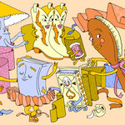

2024 Holiday Gift Guide



Is It Ever OK to Go Barefoot in Public?



How a Children’s Tennis Instructor Spends Her Sundays

Some active-duty troops also are making the trips to get psychedelic therapy, even though they risk court-martial if caught.
Image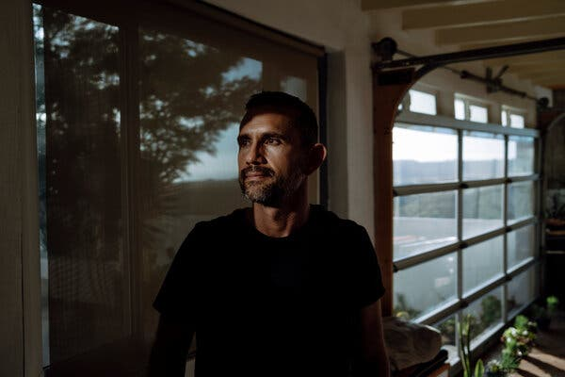
Dr. Martín Polanco set up an addiction treatment clinic called The Mission Within near Tijuana in 2001.
Image
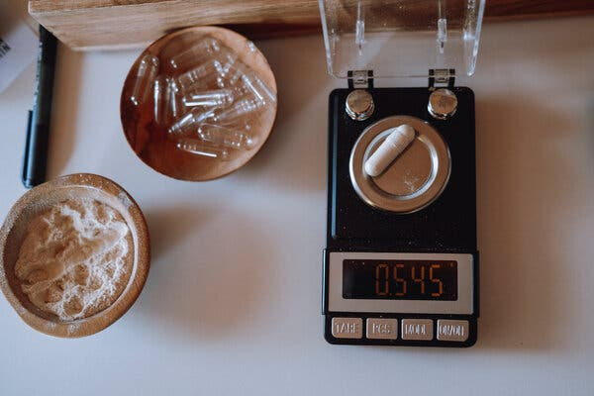
Ibogaine, a plant-derived alkaloid, is prepared during a therapy retreat at the clinic.
Their drug of choice is ibogaine, an alkaloid derived from the bark of the iboga tree. It is illegal in the United States and has a reputation for causing dark, harrowing trips. But research on animals has shown it can spur the release of natural proteins in the brain that repair and reconfigure neural networks. That leads some researchers to consider it a potential treatment for traumatic brain injury.
Psychedelic clinics typically administer ibogaine in a single dose, followed the next day by a dose of the poison of the Sonoran desert toad, called 5-MeO-DMT, a powerful short-acting psychedelic that tends to give users an overwhelming feeling of spiritual connection, earning it the nickname “the God molecule.”
In most cases, the patient uses each drug just once, and participates in psychotherapy beforehand and afterward.
Navy SEALs in particular have become involved with ibogaine, in part because several ibogaine clinics in Mexico are just a few miles from a major SEAL base in Southern California. Most wait until they have left the Navy, but dozens who are still on active duty make the trip each year, several SEALs said.
“Who can blame them?” said a high-ranking SEAL officer, who described the illegal use of psychedelics as “pervasive” among SEALs nearing the ends of their careers. “They tried talking to the psych, or taking meds, and came away frustrated. Guys want to get well, and they see this is working.”
The officer asked not to be named in order to discuss a contentious issue that the SEAL leadership has avoided acknowledging publicly.
Naval Special Warfare, the command that oversees the SEALs, said it was aware that active-duty SEALs were using ibogaine to treat brain injuries.
“While initial research shows some positive results, ibogaine remains a Schedule 1 substance, making its use illegal under U.S. law,” a spokeswoman for the command said in a statement. The Navy has “zero tolerance for drug abuse,” the spokeswoman said, and SEALs should instead seek care through “approved medical channels.”
Image
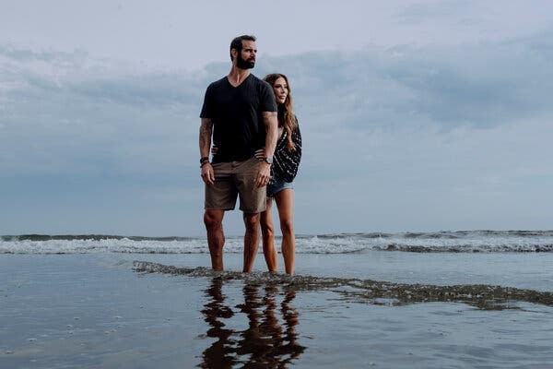
Marcus Capone with his wife, Amber, in Coronado, Calif. Mr. Capone was one of the first SEAL veterans to try ibogaine, in 2017.
Image

The view from the clinic near Tijuana, Mexico.
Ibogaine has been used in traditional ceremonies in Africa for centuries. It gained attention in the United States in the 1960s as a potential anti-addiction therapy.
A push in the 1980s and 1990s to legalize ibogaine for addiction treatment in the United States foundered over safety concerns, because ibogaine can cause dangerous heart arrhythmia.
With no legal venue in the United States, addiction treatment centers using ibogaine sprang up in the Caribbean and Mexico.
Image
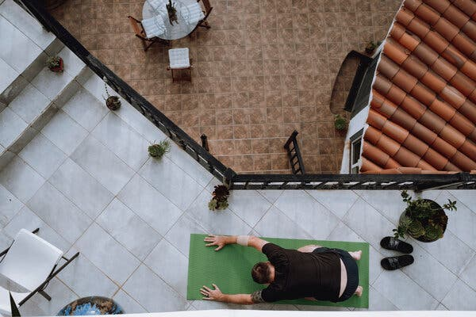
A participant stretched at the clinic on the first day of the retreat.
Image

A staff member preparing 5-MeO-DMT, a powerful short-acting psychedelic derived from the poison of a toad.
The doctor who runs the clinic where the van of veterans was headed, Martín Polanco, said he set up a clinic, now called The Mission Within, near Tijuana, Mexico, in 2001 to treat drug addiction.
The focus of his practice shifted in 2016, he said, when he treated a retired SEAL. Afterward, the SEAL noticed that the drug had not only ended his heroin craving, but also reduced the anger, depression and insomnia he associated with PTSD.
Word spread in the SEAL community, Dr. Polanco said, and “now almost my whole practice is just treating Special Operations.”
Marcus Capone was one of the first SEAL veterans to try ibogaine, in 2017. After 13 years of combat deployments and explosives training, he had been diagnosed with PTSD and a brain injury. He would wake up in the night screaming from headaches. He was angry, depressed and sometimes violent.
“I would find myself in a daze, driving down the highway at 30 miles per hour, just completely checked out,” he said in an interview at his home in Coronado, Calif.
He tried psychotherapy, prescription medications, and nearly everything else the military and veterans’ health care systems had to offer, without success, he said. Then another SEAL veteran told him about ibogaine.
“We thought it was crazy,” said his wife, Amber Capone. “Neither of us had ever done drugs before. But we were at the end of our rope.”
Mr. Capone said he returned from treatment able to sleep, concentrate and control his emotions. He repaired his marriage, got a business degree and started his own company.
The couple founded a nonprofit called Veterans Exploring Treatment Solutions to pay for ibogaine therapy for other veterans. Other nonprofits are doing the same.
Ibogaine’s reputation has spread beyond the SEALs to other military communities hit by brain injuries, including elite Navy speedboat teams and fighter pilots.
On a Friday at the clinic in Tijuana, it was go time for the van of veterans.
They arrived at a white stucco house where Dr. Polanco holds retreats. Staff members fitted each man with an IV catheter. Because ibogaine can strain the heart, participants are given an intravenous magnesium solution to regulate their heartbeat, and are monitored by a cardiologist.
Dr. Polanco said he has not encountered heart issues in veterans he has treated.
As the veterans waited, they started to talk about what had brought them.
A former C.I.A. paramilitary operations officer named Philip tapped his head and said, “There is something wrong, I just don’t know what it is.”
An Army veteran, Konnor da Luz, who had been hit by a blast in Afghanistan, nodded solemnly. “It’s like I haven’t been right since I got back.”
Image
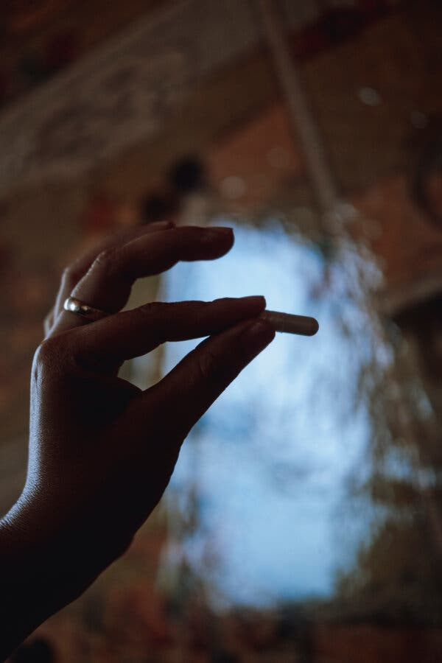
A staff member with an ibogaine pill. The doses are customized to each veteran’s weight.
Image
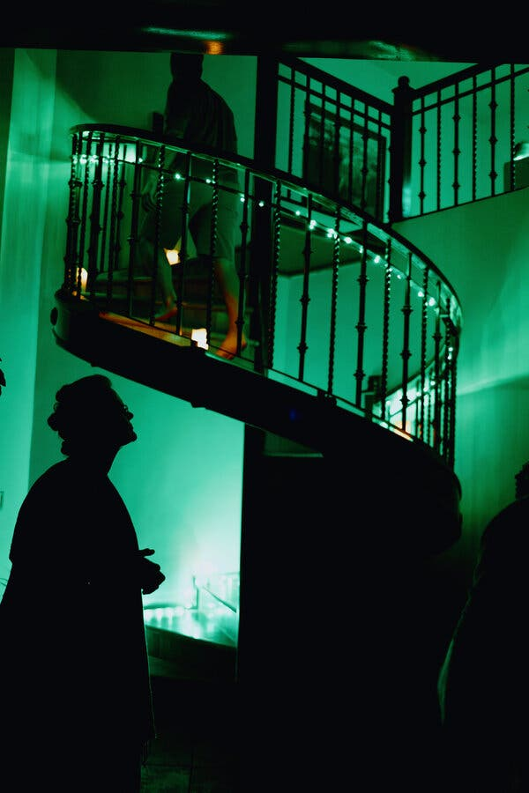
After a brief ceremony, the veterans moved to a communal bedroom to wait for the ibogaine to take effect.
Matt, a former SEAL, told the others he was back for a second ibogaine experience. He said his first, two years earlier, had dramatically eased his problems with depression and alcohol.
“Haven’t had a drink since,” he said. “But my wife noticed I’ve just been edgy lately, a little more angry, forgetful. She suggested I come back. Maybe I have some more work to do.”
At sunset, there was a brief ceremony, some words of guidance, and then each man swallowed a pill.
The veterans settled on mattresses in a communal bedroom. Candles and tapestries gave it a hippy dorm-room vibe, but there were also heart monitors and stands holding IV fluid by each bed. The men slipped on eye covers and headphones, and waited for the drug to kick in.
An ibogaine trip is not known for being pleasant. Time, space, light and sound all splinter, and reality abandons the user for hours that can feel like eons. The drug also usually makes people physically ill.
Several veterans spent hours retching into bowls placed by their mattresses. When the vomiting subsided, the men lay quietly, seeming to sleep.
“At this point, they are not even in their own consciousness, they are just out in the universe,” whispered Mark Jackson, a staff member watching over the men. “Some see their ancestors and get forgiveness. Some have their soul ripped out over and over. Some see nothing. But no matter what they see, the biochemical benefits for the brain are the same.”
Image
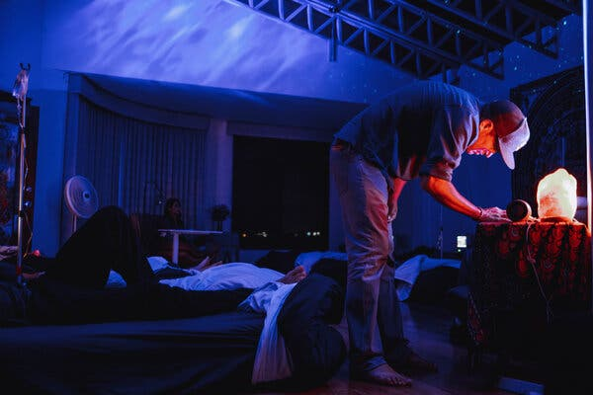
Mark Jackson, a staff member watching over the men, adjusted the music in the communal room.
Image
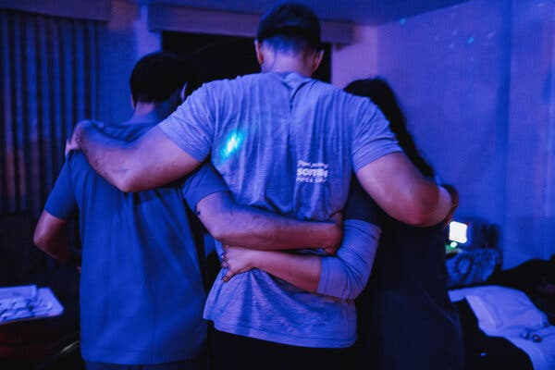
Staff members assisted a man during the ibogaine therapy. Several of the veterans started retching repeatedly into bowls placed by their mattresses.
Stanford University researchers recently tracked 30 veterans who went through the treatment. The study, published in January, found that symptoms of depression and PTSD abruptly dropped by nearly 90 percent, and remained lower a month later. The team also found improvements in cognitive performance, including the ability to learn and remember.
M.R.I. scans indicated that some regions of the veterans’ brains were thicker a month after treatment than they were before, said Dr. Nolan Williams, an associate professor of psychiatry at Stanford who led the study: “We are seeing physical changes to the brain — some kind of neuro repair phenomenon that you don’t see with any kind of modern established therapy or prescription drugs.”
Another research group at the University of Texas is seeing similar improvements in mental health.
“The question is, will it last?” said Dr. Charles Nemeroff, co-director of the Center for Psychedelic Research and Therapy at the University of Texas’ Dell Medical School. “We don’t know how durable the effects are yet.”
At the clinic near Tijuana, the men slept late into Saturday and tottered downstairs on unsteady legs.
“That was terrible,” a Marine veteran named John said. “Everything was blackness and I was alone for eternity.”
“Yeah,” said the C.I.A. man. “Let’s never go to that bar again.”
The Green Beret came down smiling and described seeing tiny hummingbird elves that healed his body while the spirit of his grandmother flowed into his soul.
A retired Army Special Forces sniper named Thomas who was listening turned to Dr. Polanco: “Is any of this supposed to make sense?”
“It’s a process that will continue to unfold over the next few weeks,” Dr. Polanco replied. “Often the meaning reveals itself.”
Image
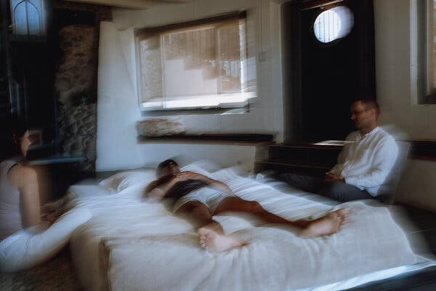
Clinic staff members monitored Konnor da Luz, an Army veteran, after he took a dose of 5-MeO-DMT.
Image
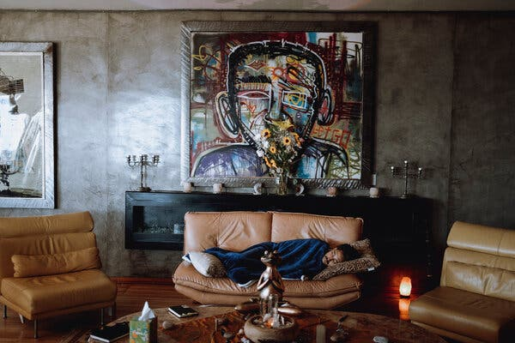
Mr. da Luz rested on a couch in the clinic.
The men awoke Sunday surprised by how good they felt. The Green Beret said he slept well for the first time in years.
Next came the toad poison. The men smoked it one by one, then slumped back in a daze. The psychedelic effect lasts only about 15 minutes, but many users experience a wild realm of infinitely expanding consciousness.
“It wasn’t a vision — I didn’t see anything, but I felt everything,” the sniper said afterward. He had a look of astonishment, and tears streaked down his cheeks.
“I had this overwhelming feeling that — I’m good,” he said, and then laughed.
He said 10 years of therapy in the Army had yielded little progress, and added, “This stuff here could have saved the Army a lot of money.”
Two months later, the men said in interviews that the retreat had drastically improved their sleep, moods, relationships and outlook on life.
The sniper said he had stopped smoking and drinking, and no longer needed cannabis to sleep. He felt kinder, more at peace. His thinking was clearer, his memory better.
“It hasn’t worn off,” he said, and added, “I can’t tell you how it happened, but it worked.”
Image

Veterans on the last evening of their ibogaine therapy retreat at the clinic.
If you are having thoughts of suicide, call or text 988 to reach the 988 Suicide and Crisis Lifeline or go to SpeakingOfSuicide.com/resources for a list of additional resources.

